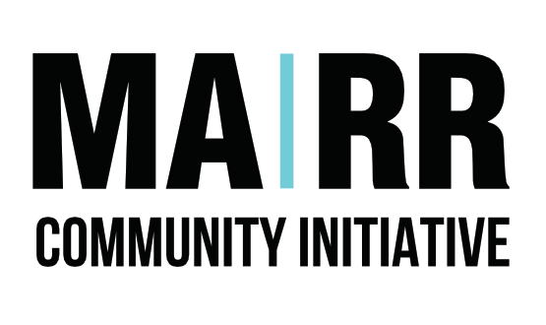
DATA SHARING AGREEMENT
This agreement does not convey any enforceable rights or actions upon the parties to this agreement. Where enforceable rights are required, or the law specifies, parties should agree to a Data Processing Agreement.

This Data Sharing Agreement is made on

[Insert date]
1 1 | Between:  Mutual Aid Road Reps & [INSERT ORGANISATIONS NAME]
2 2 | Purpose, objectives of the information sharing:  Is to share information relating to an incoming referral and any subsequent contact required between Mutual Aid Road Reps CIC & [INSERT ORGANISATIONS NAME]
3 3 | Controller/s  Mutual Aid Road Reps CIC & - Kate Belmonte  Contact Number: 07739965596  Email: kate@mutualaidmedway.org.uk  [INSERT ORGANSATIONS NAME] – [DATA CONTROLLERS NAME]  Contact Number: [INSERT HERE}  Email: [INSERT HERE]
4 4 | Processor/s  Mutual Aid Road Reps CIC – Area Coordinators, Subgroup Coordinators & Subgroup Admin Team  [INSERT ORGANISATIONS NAME] – [DATA PROCESSORS ROLES]
5 5 | Purpose of data sharing:  To allow for incoming referrals from [INSERT ORGANISATIONS NAME HERE].  To provide background to incoming referrals from [INSERT ORGANISATIONS NAME HERE].  To provide a professional service for any referrals received from [INSERT ORGANISATIONS NAME HERE].
6 6 | Type of Data to be shared:  Name  Address  Mobile telephone number  Landline telephone number  Email address  Age  Medical information which may be relevant to our service e.g. mental health condition  Next of kin name & contact number (for emergencies)
7 | Legal Basis for sharing data:  Consent: Has the individual given clear consent for us to process their personal data for the explicit use in the role of befriending or in the general undertaking of tasks such as shopping or prescription collections.  YES / NO
8 | How will the data sharing be carried out?  LGC referrals must be sent via the Let’s Get Chatty referral form: https://forms.gle/1ECWaD8AXZJEEMcU7 the responses of which are held in a secure password protected location.  MARR referrals must be emailed to kate@mutualaidmedway.org.uk
9 | Accuracy of the data being shared:  New referrals will be entered on to our TeamBee platform, a password protected CRM system, specifically for managing the information of our users.
10 | Rectification of data that has been shared:  Any information, which is found to be inaccurate will be chased up with organisation in section 1.
11 | Data Retention:  We will keep all records for a period of 2 years post referral unless the user no longer requires our services, we will then erase all sensitive data but retain the first name & surname of the user.
12 | Commencement of agreement:  The agreement will come into force with the first referral and remain in place until a time where our joint working is no longer required or feasible.
13 | Review of agreement:  The document will be reviewed 12 months from signature.
14 | Review period:  This review may take up to 28 days to process.
15 | Ending the agreement:  Should either Mutual Aid Road Reps CIC or [INSERT ORGANISATIONS NAME] wish to terminate the agreement any information shared shall remain the sole responsibility of the information bearer.
16 | End date:  This agreement will automatically end on 14th March 2023 unless the organisation and/or individual wishes to terminate earlier.
17 | Signatories:  Mutual Aid Road Reps CIC  Name: Kate Belmonte  Position: Director  Signature: ________________________________________________  Date: ________________  [INSERT ORGANISATIONS NAME]  Name:___________________________________________________  Position:______ ___________________________________________  Signature: ________________________________________________  Date: ________________

